Digital Design Diploma

# **Assignment 5**

# **FSM & Memories**

|  |  |
| --- | --- |
| **Name** | Kareem Hassan Atif |
| **Group** | G2 |

**Submitted to: Eng. Kareem Waseem**

**1. Tesla Car:**

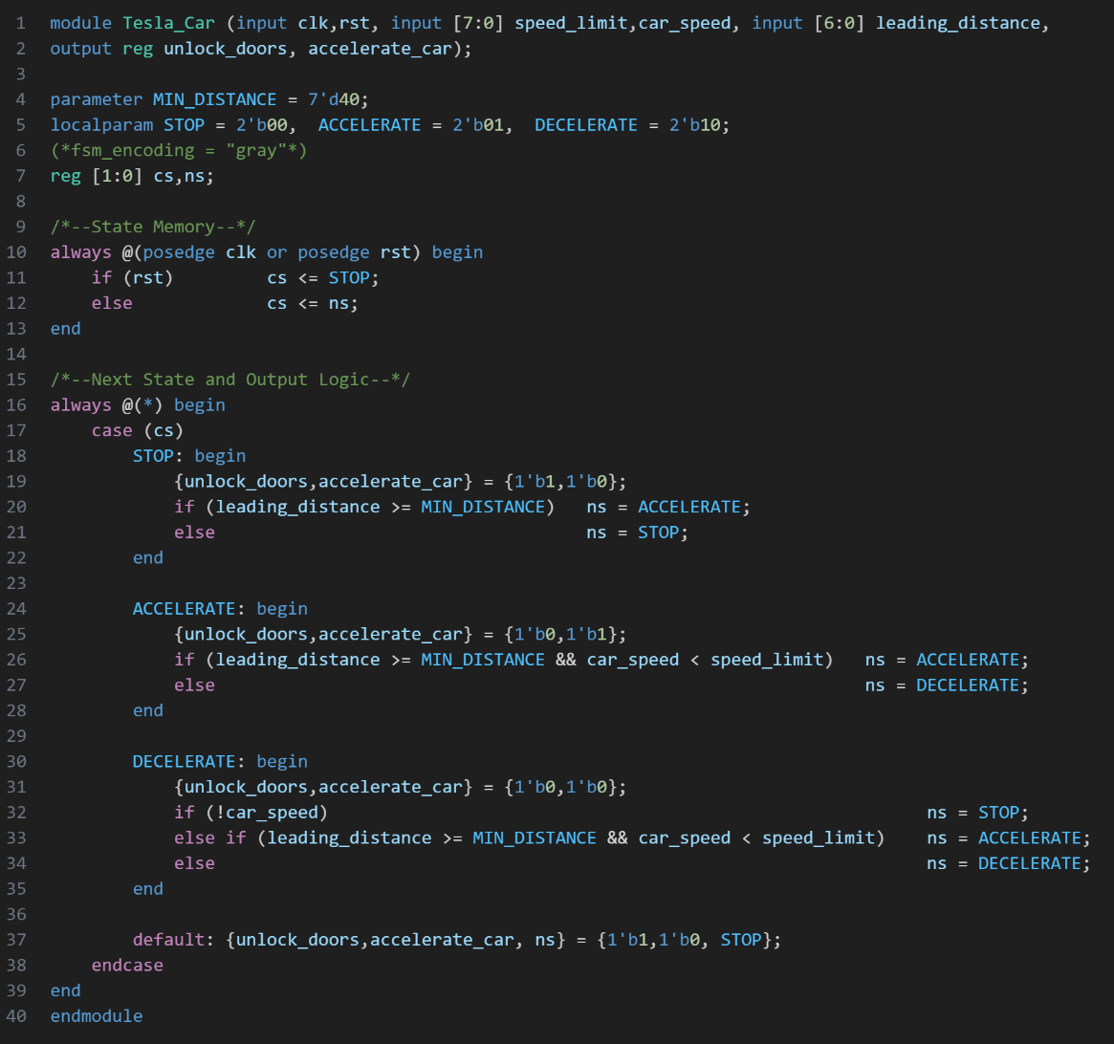

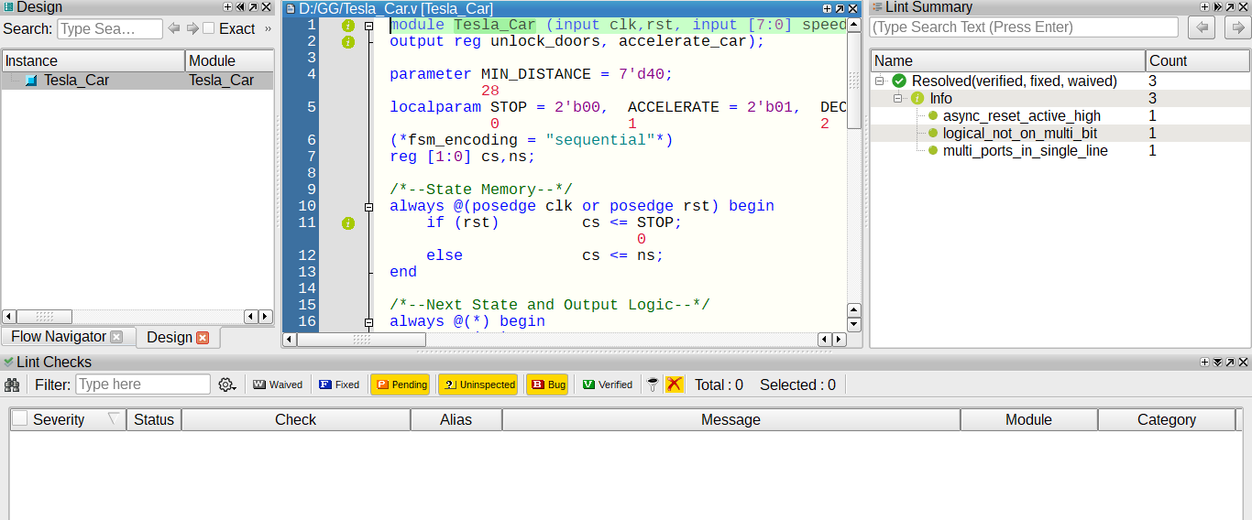

Figure 1: Q1 Code

Figure 2: Q1 Linting

**صورة تحتوي على نص, لقطة شاشة, برمجيات

قد يكون المحتوى المعد بواسطة الذكاء الاصطناعي غير صحيح.**

Figure 3: Q1 Testbench

**صورة تحتوي على نص, لقطة شاشة, الخط

قد يكون المحتوى المعد بواسطة الذكاء الاصطناعي غير صحيح.صورة تحتوي على نص, لقطة شاشة, عرض, برمجيات

قد يكون المحتوى المعد بواسطة الذكاء الاصطناعي غير صحيح.**

Figure 4: Q1 Wave

**صورة تحتوي على نص, لقطة شاشة, الخط, برمجيات

قد يكون المحتوى المعد بواسطة الذكاء الاصطناعي غير صحيح.**

Figure 6: Q1 Constraint File

Figure 5: Q1 DO File

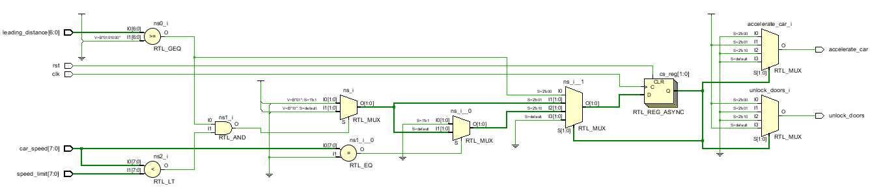 **1.1 Gray Encoding:**

Figure 7: Q1 RTL (Gray)

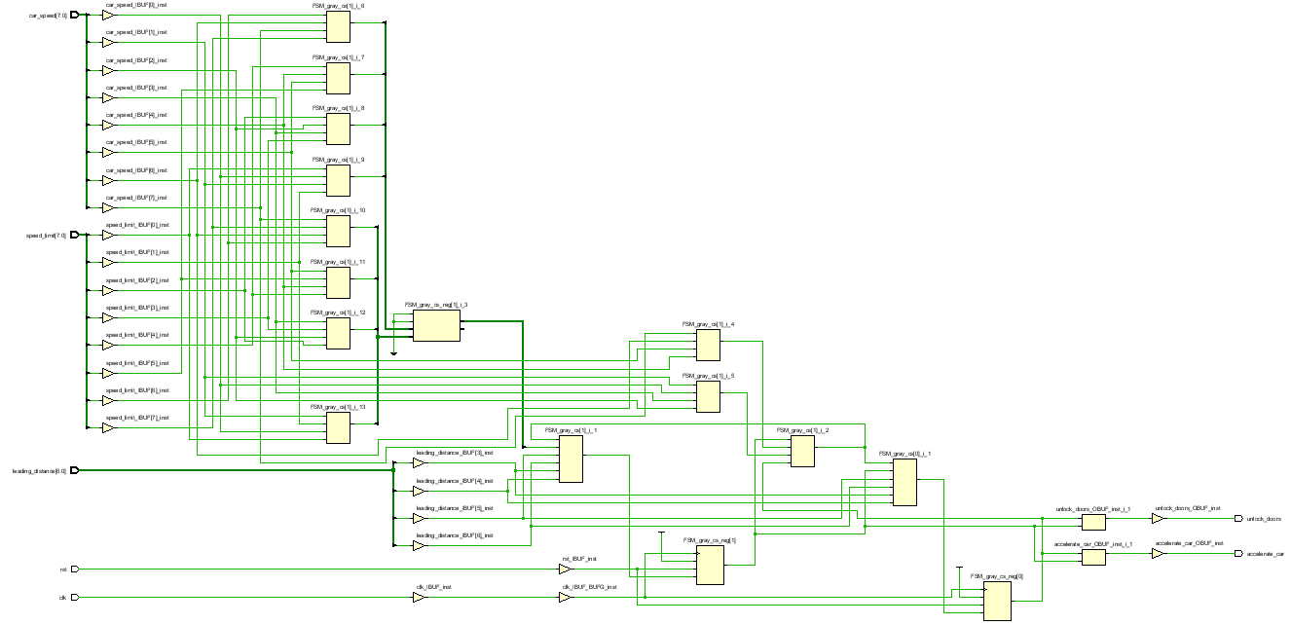

Figure 8: Q1 Synthesis (Gray)

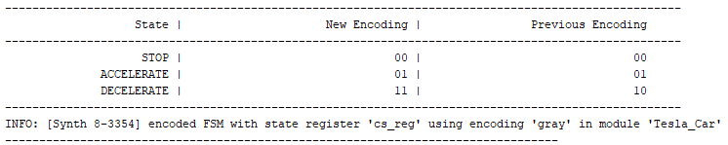

Figure 9: Q1 Encoding Report (Gray)

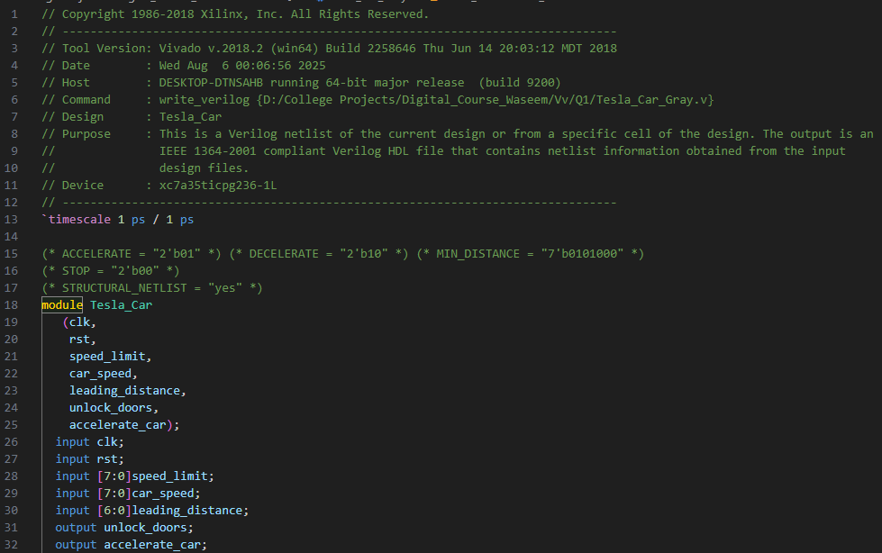

Figure 10: Q1 Netlist (Gray)

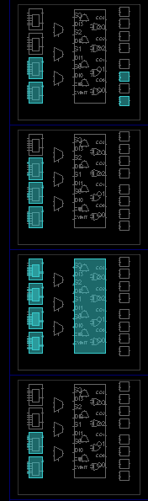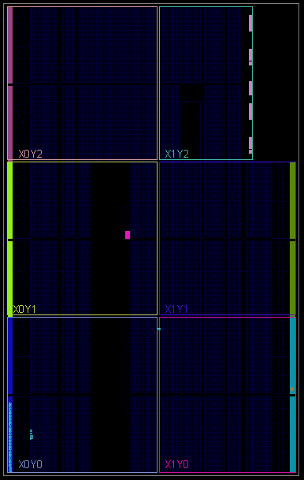

Figure 12: Q1 Zoomed Device (Gray)

Figure 11: Q1 Device (Gray)

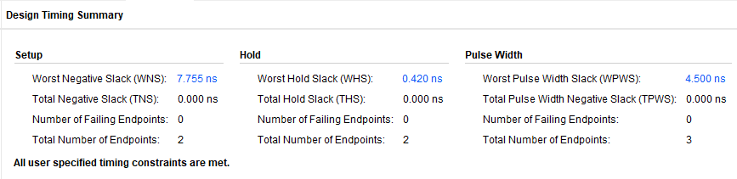

Figure 13: Q1 Synthesis Timing Report (Gray)

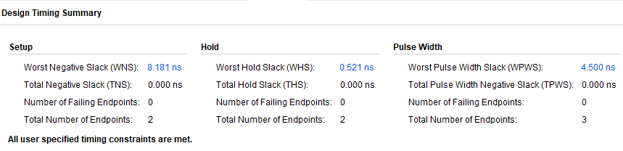

Figure 14: Q1 Implementation Timing Report (Gray)

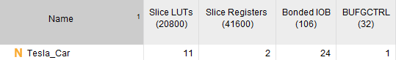

Figure 15: Q1 Synthesis Utilization Report (Gray)

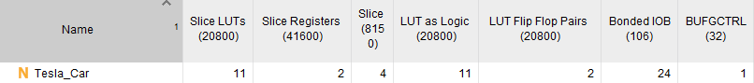

Figure 16: Q1 Implementation Utilization Report (Gray)

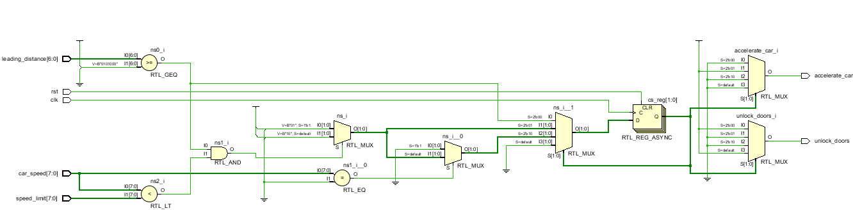 **1.2 Sequential Encoding:**

Figure 17: Q1 RTL (Sequential)

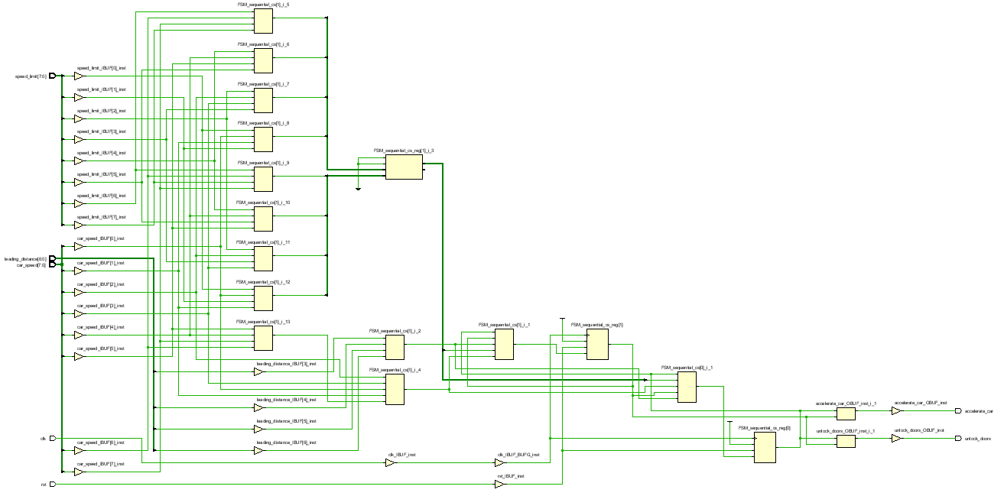

Figure 18: Q1 Synthesis (Sequential)

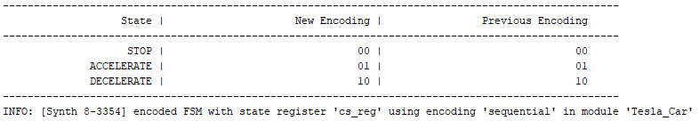

Figure 19: Q1 Encoding Report (Sequential)

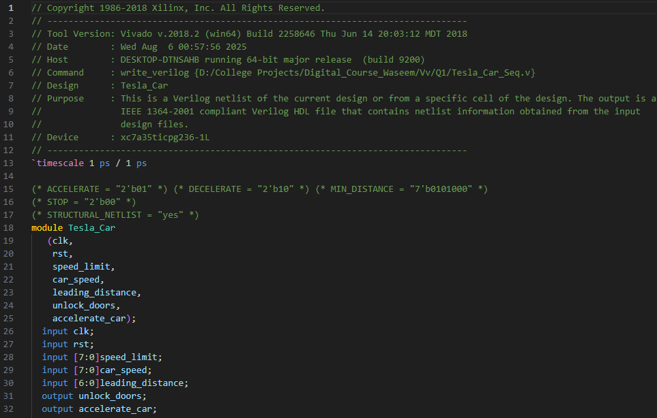

Figure 20: Q1 Netlist (Sequential)

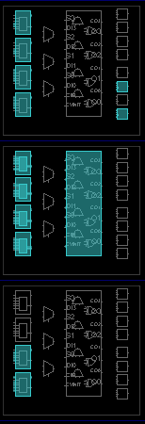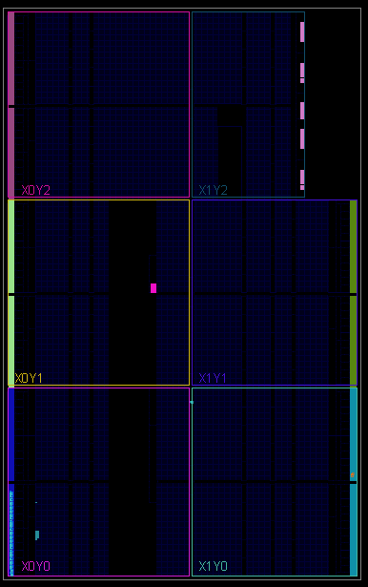

Figure 21: Q1 Device (Sequential)

Figure 22: Q1 Zoomed Device (Sequential)

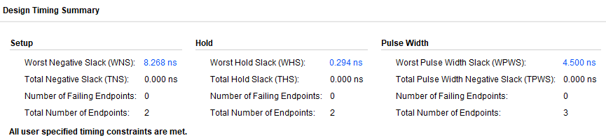

Figure 23: Q1 Synthesis Timing Report (Sequential)

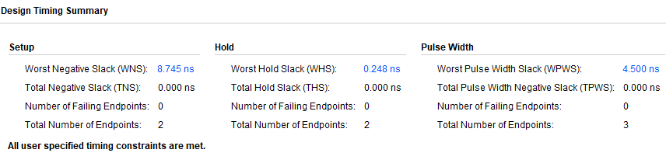

Figure 24: Q1 Implementation Timing Report (Sequential)

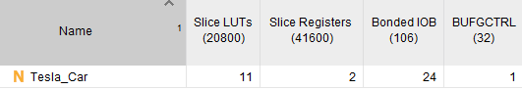

Figure 25: Q1 Synthesis Utilization Report (Sequential)

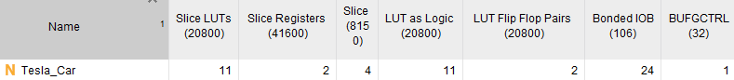

Figure 26: Q1 Implementation Utilization Report (Sequential)

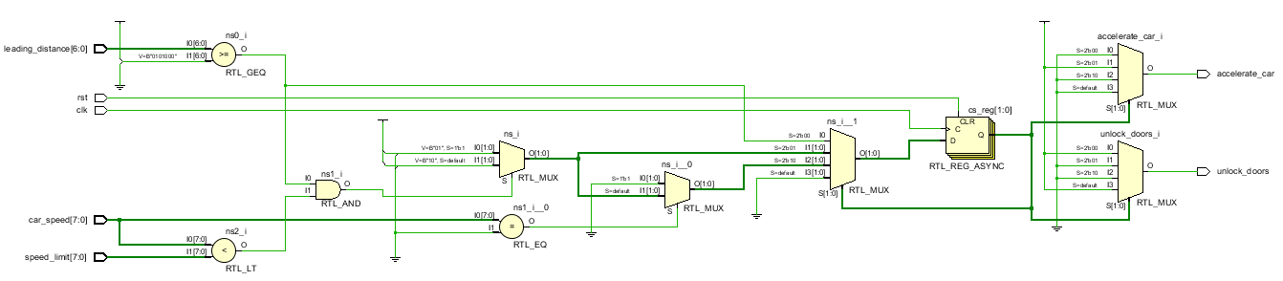 **1.3 One-Hot Encoding:**

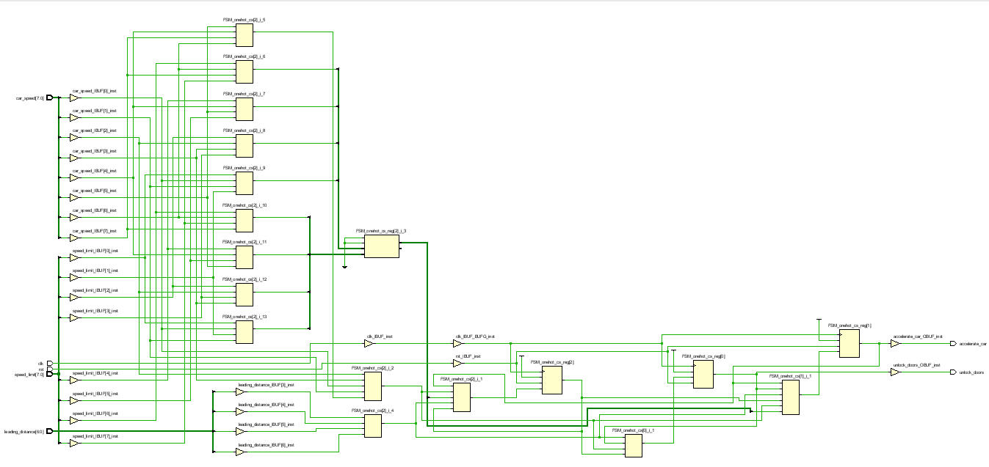

Figure 27: Q1 RTL (One-Hot)

Figure 28: Q1 Synthesis (One-Hot)

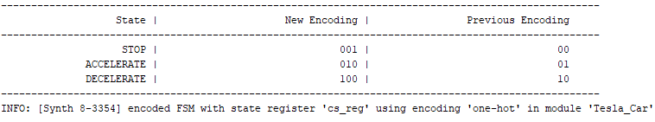

Figure 29: Q1 Encoding Report (One-Hot)

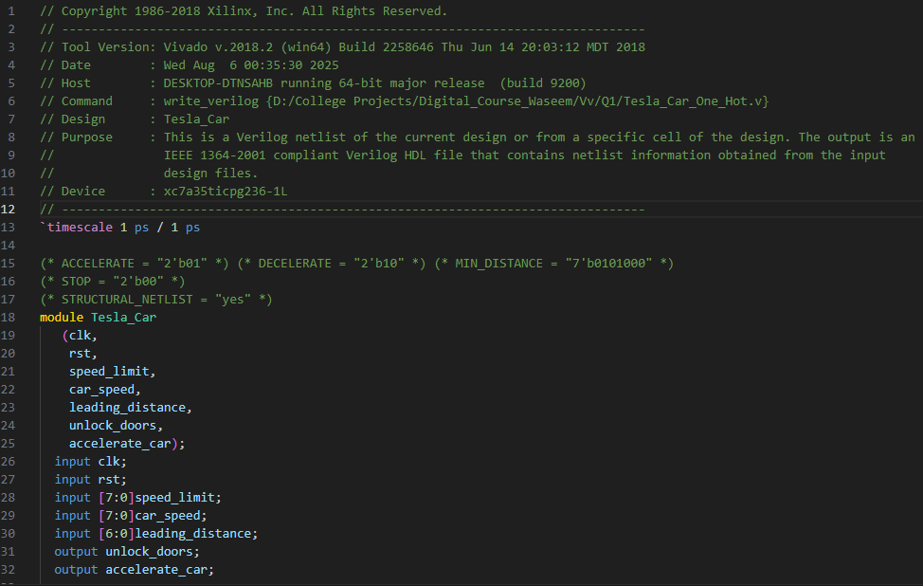

Figure 30: Q1 Netlist (One-Hot)

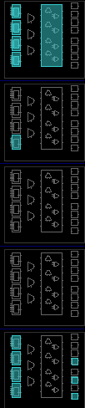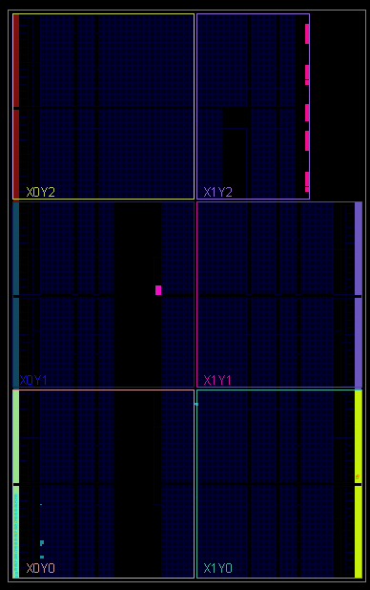

Figure 31: Q1 Device (One-Hot)

Figure 32: Q1 Zoomed Device (One-Hot)

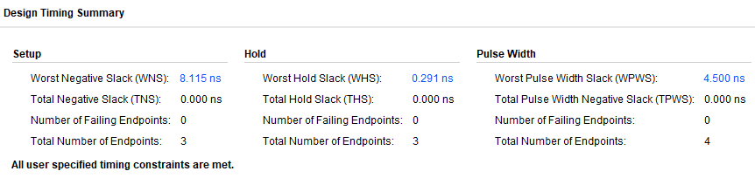

Figure 33: Q1 Synthesis Timing Report (One-Hot)

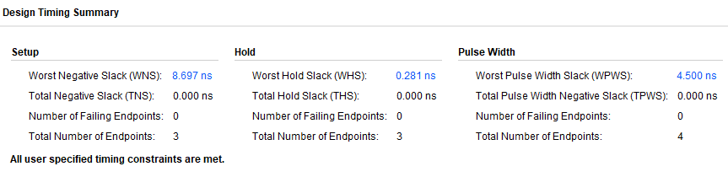

Figure 34: Q1 Implementation Timing Report (One-Hot)

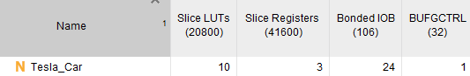

Figure 35: Q1 Synthesis Utilization Report (One-Hot)

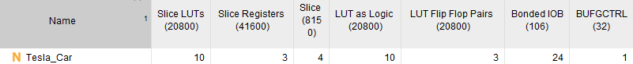

Figure 36: Q1 Implementation Utilization Report (One-Hot)

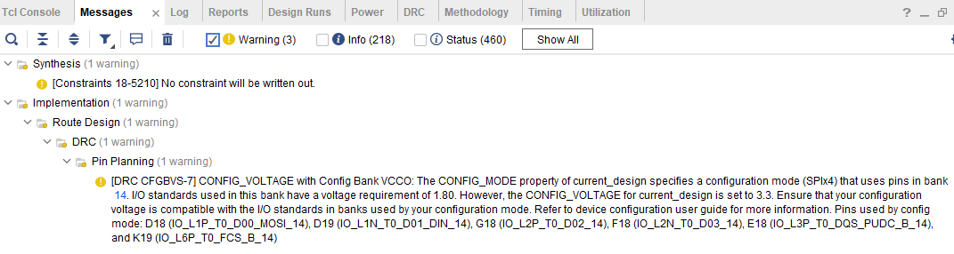

Figure 37: Q1 Messages

Sequential and Gray encodings use two flip flops, while one-hot encoding uses three flip flops. Sequential encoding has the highest setup slack. So, Sequential is the best encoding in this case, as it has the highest slack which means higher frequency clock, with the least number of registers used.

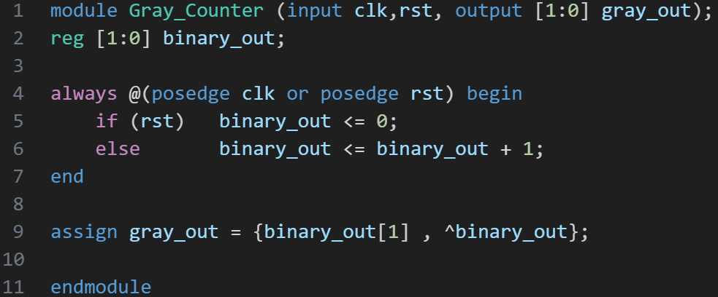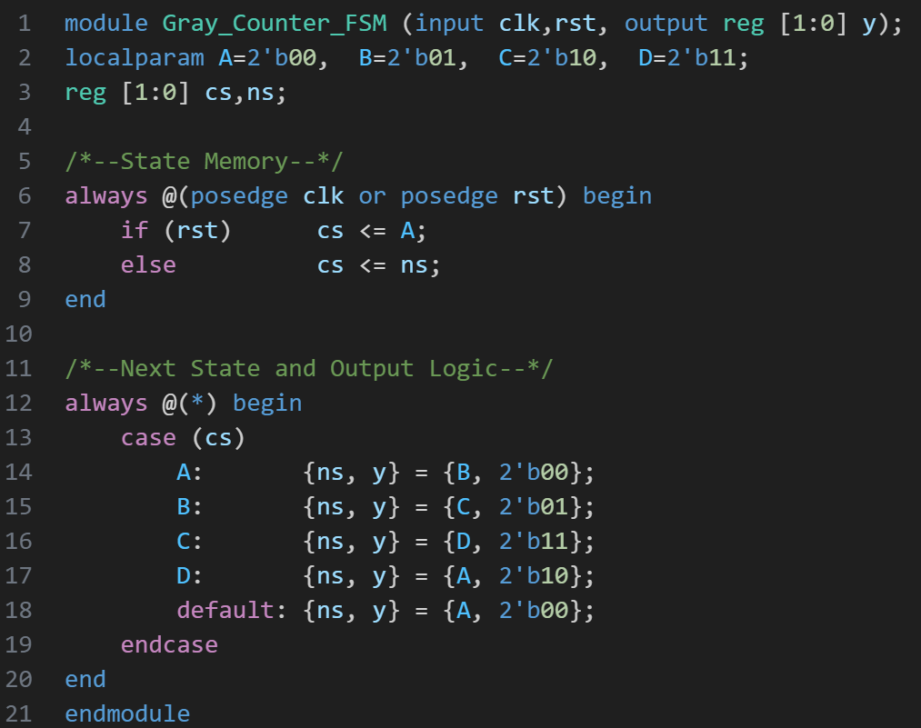**2.** **Gray Counter FSM:**

Figure 39: Q2 Golden Model Code

Figure 38: Q2 Code

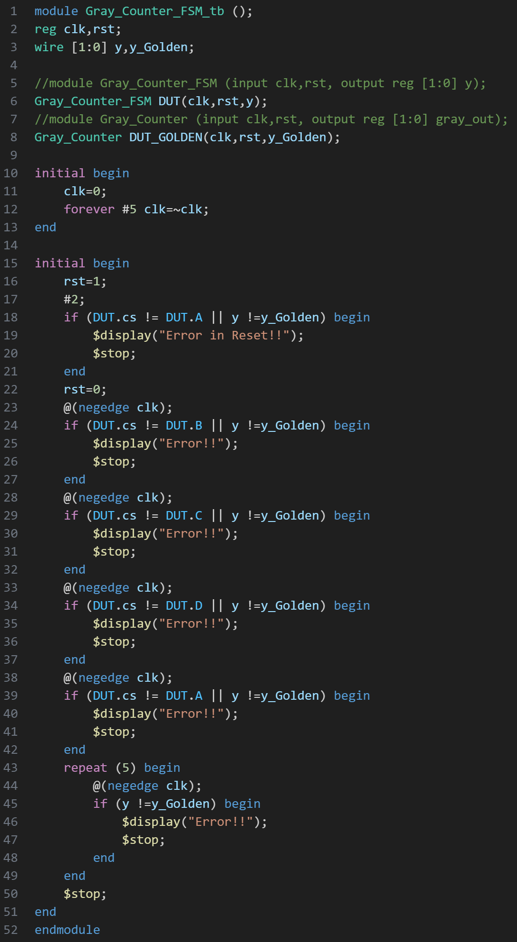

Figure 40: Q2 Testbench

**صورة تحتوي على نص, برمجيات, عرض, أيقونة الحاسوب

قد يكون المحتوى المعد بواسطة الذكاء الاصطناعي غير صحيح.**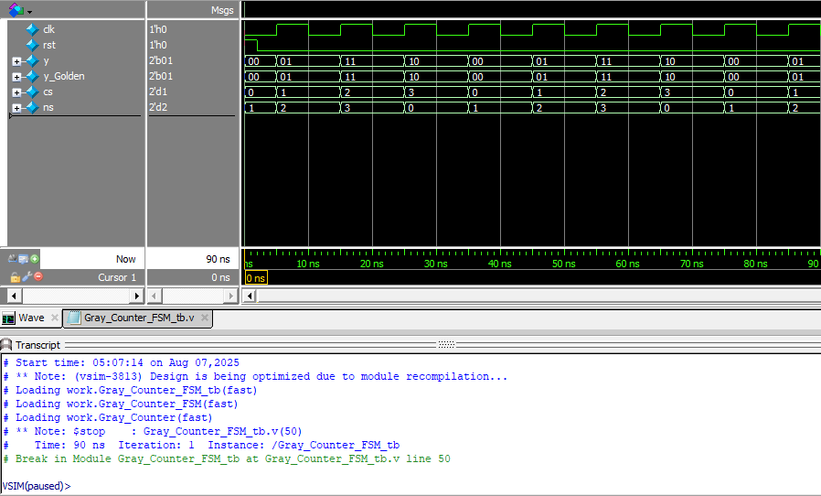

Figure 42: Q2 Linting

Figure 41: Q2 Wave

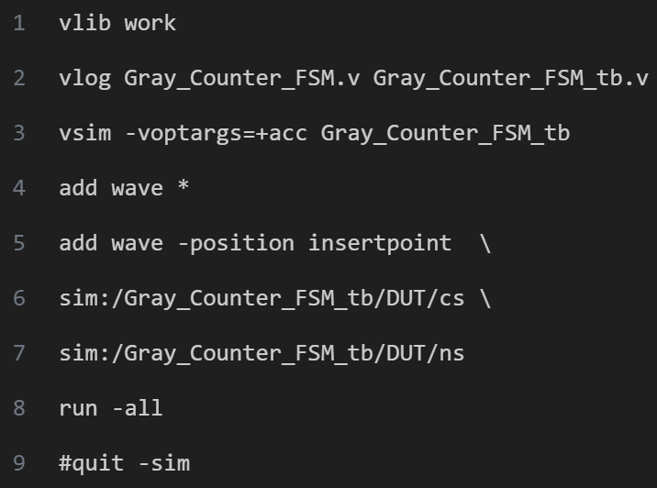

Figure 43: Q2 DO File

**صورة تحتوي على نص, لقطة شاشة, الخط

قد يكون المحتوى المعد بواسطة الذكاء الاصطناعي غير صحيح.**

Figure 44: Q2 Constraint File

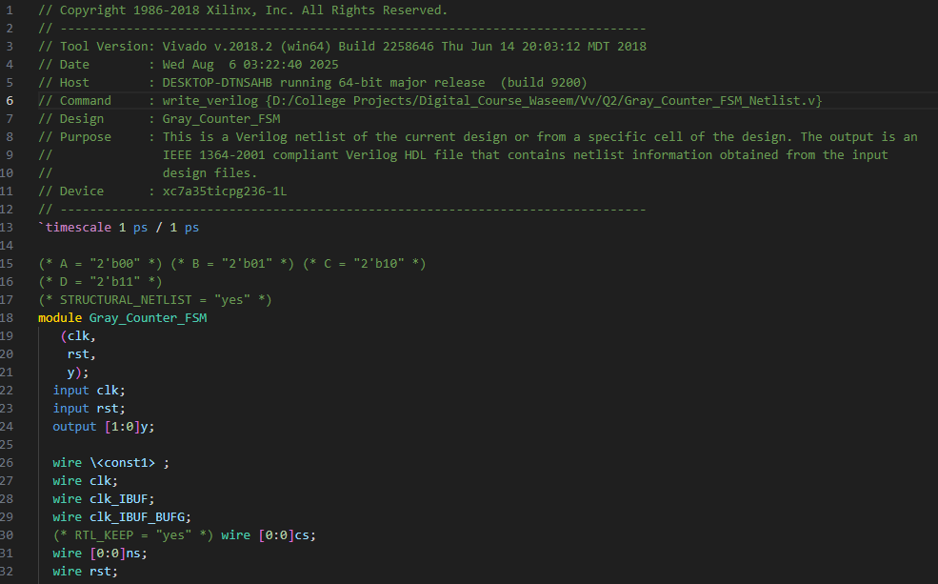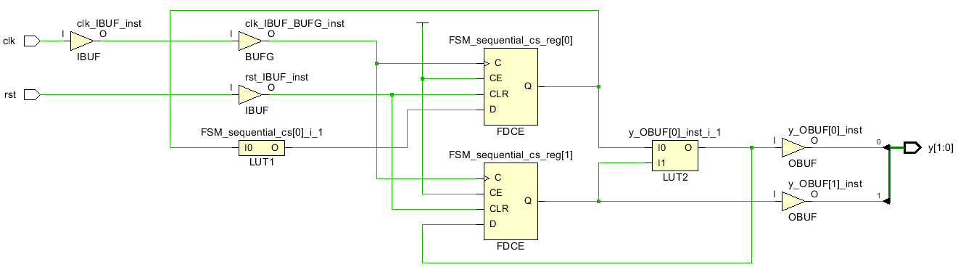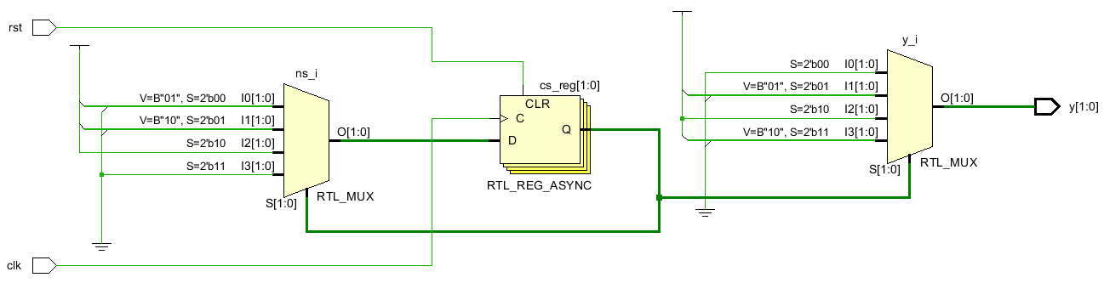

Figure 47: Q2 Netlist

Figure 46: Q2 Synthesis

Figure 45: Q2 RTL

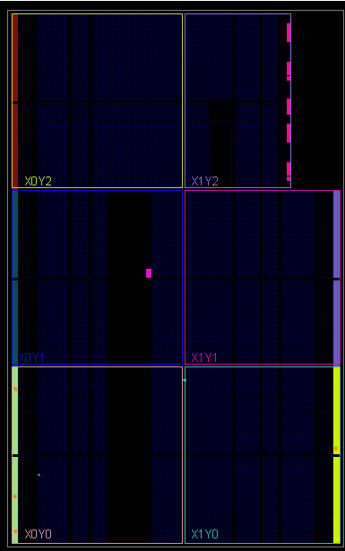

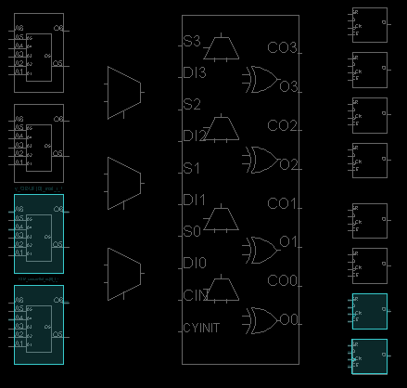

*Figure 49: Q2 Zoomed Device*

Figure 48: Q2 Device

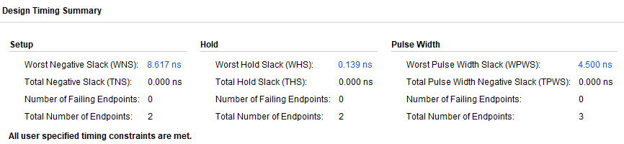

*Figure 50: Q2 Synthesis Timing Report*

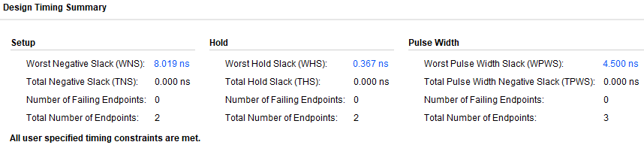

*Figure 51: Q2 Implementation Timing Report*

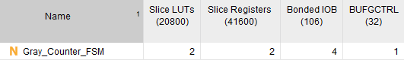

*Figure 52: Q2 Synthesis Utilization Report*

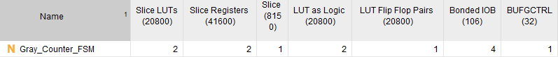

*Figure 53: Q2 Implementation Utilization Report*

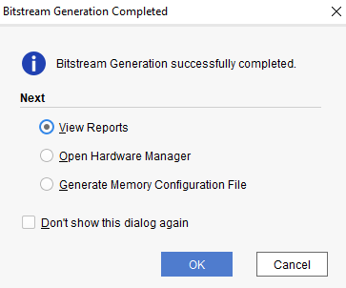

*Figure 54: Q2 Bitstream*

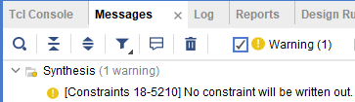

*Figure 55: Q2 Messages*

**3. Sequence Detector (111):**

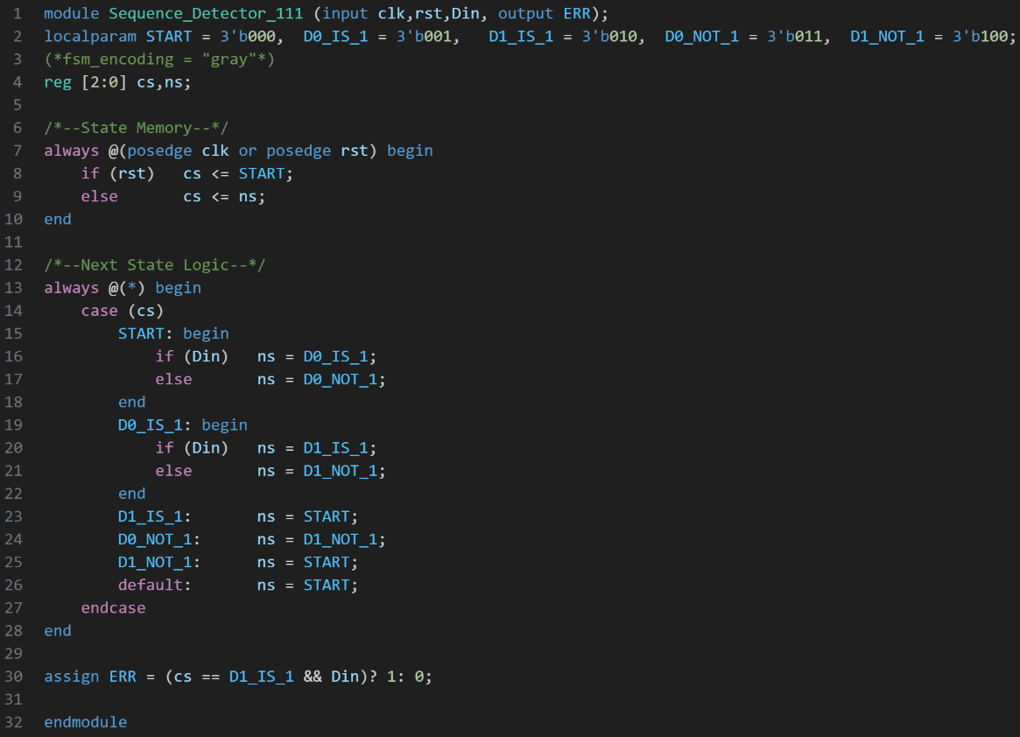

Figure 56: Q3 Code

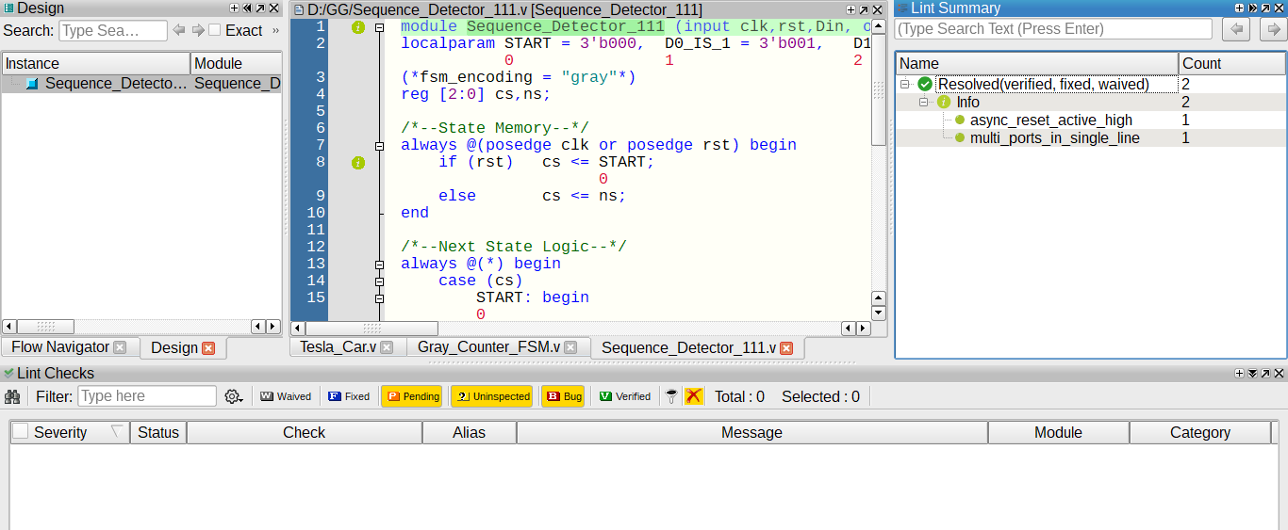

Figure 57: Q3 Linting

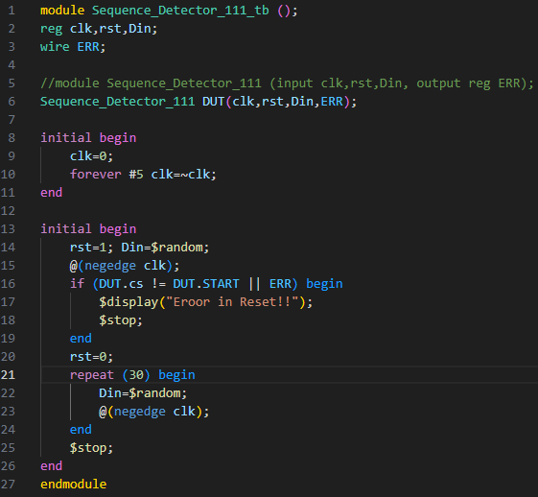

Figure 58: Q3 Testbench

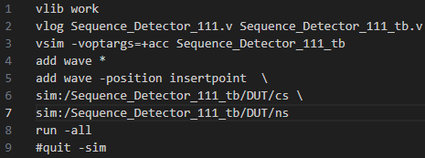

Figure 59: Q3 DO File

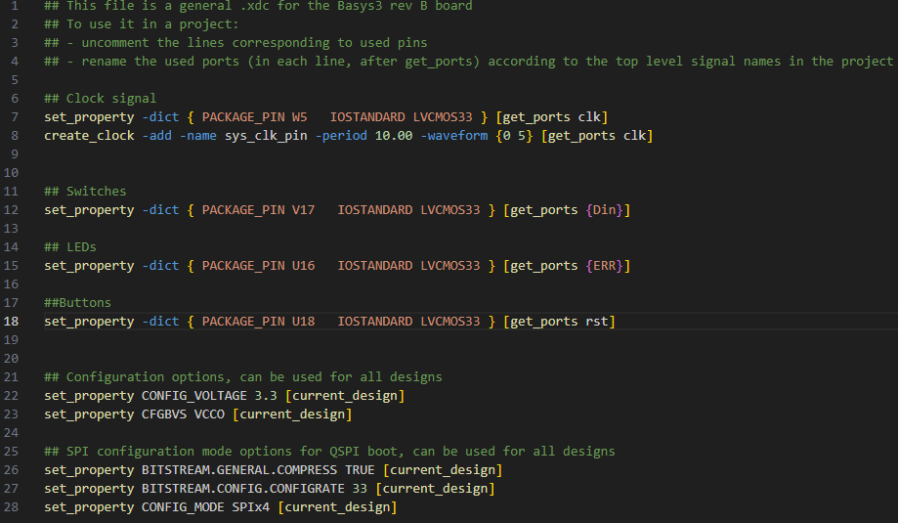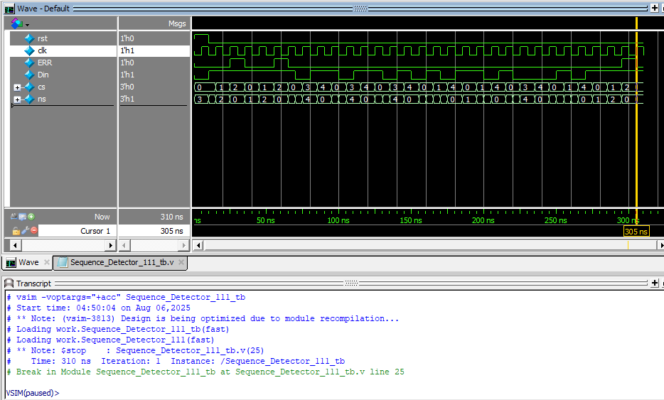

Figure 60: Q3 Wave

Figure 61: Q3 Constraint File

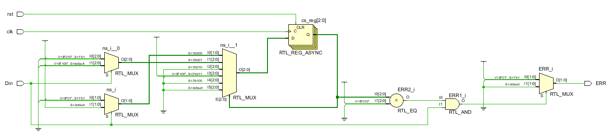 **3.1 Gray Encoding:**

Figure 62: Q3 RTL (Gray)

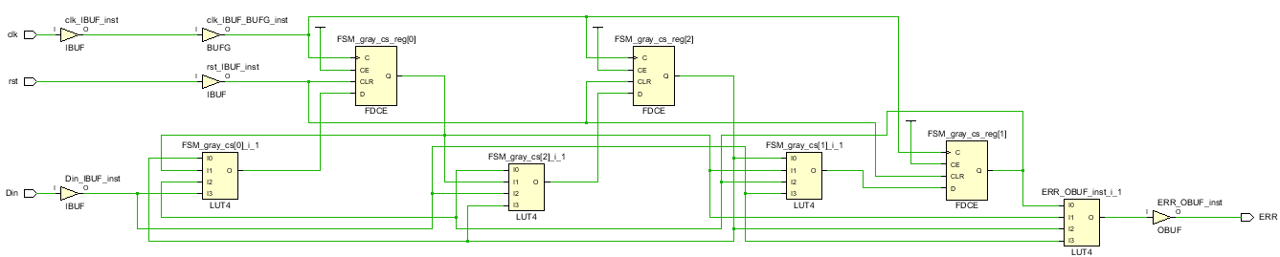

Figure 63: Q3 Synthesis (Gray)

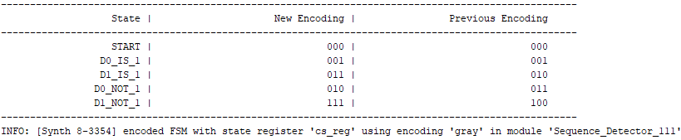

Figure 64: Q3 Encoding Report (Gray)

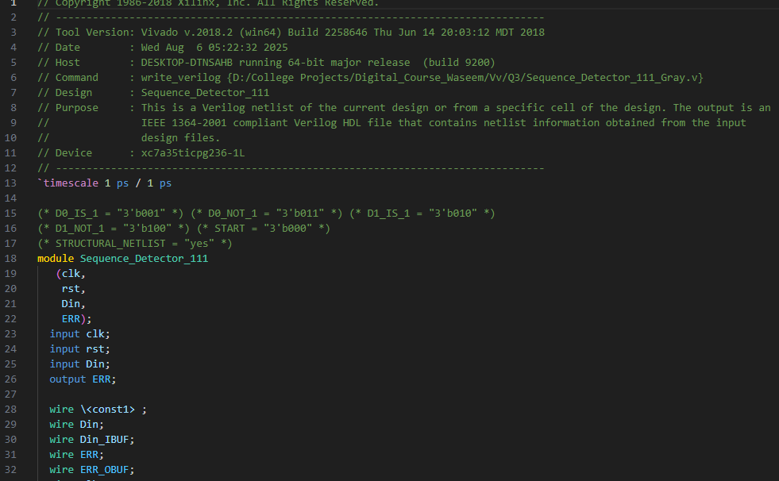

Figure 65: Q3 Netlist (Gray)

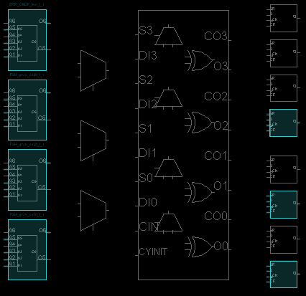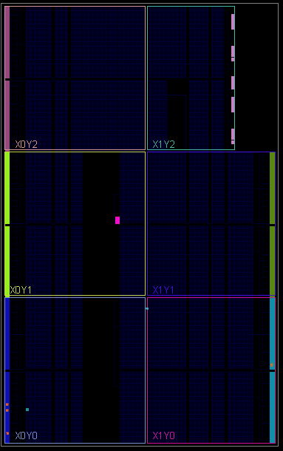

Figure 67: Q3 Zoomed Device (Gray)

Figure 66: Q3 Device (Gray)

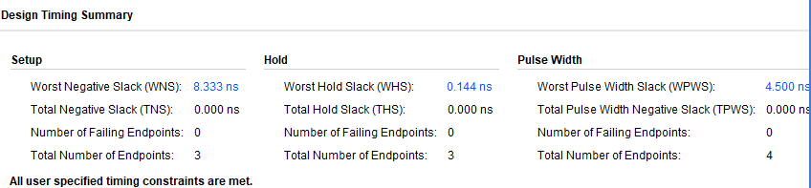

Figure 68: Q3 Synthesis Timing Report (Gray)

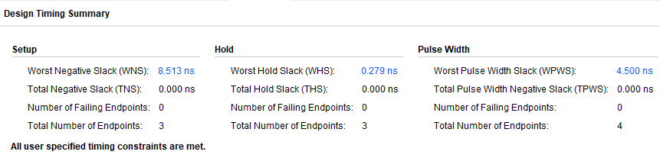

Figure 69: Q3 Implementation Timing Report (Gray)

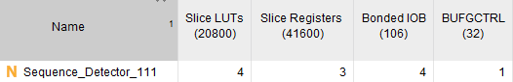

Figure 70: Q3 Synthesis Utilization Report (Gray)

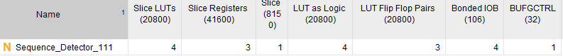

Figure 71: Q3 Implementation Utilization Report (Gray)

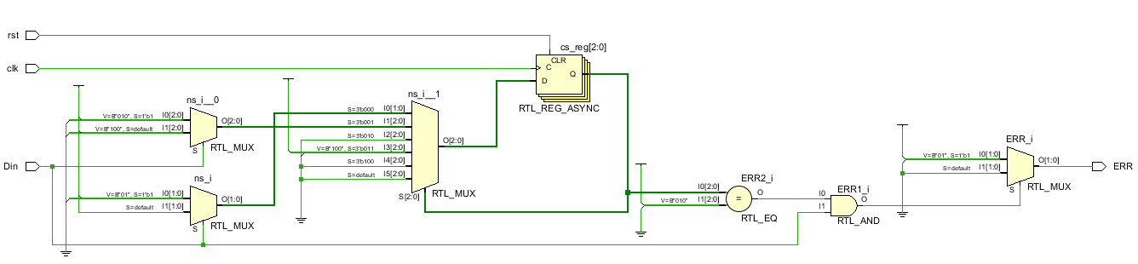 **3.2 Sequential Encoding:**

Figure 72: Q3 RTL (Sequential)

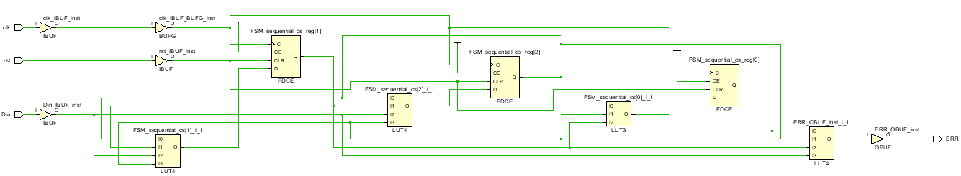

Figure 73: Q3 Synthesis (Sequential)

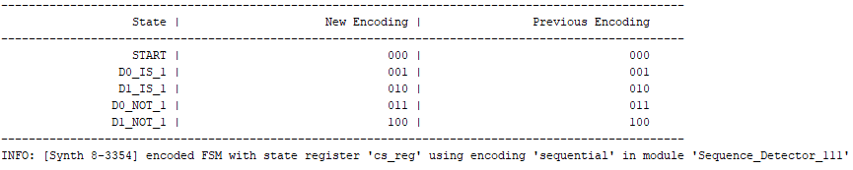

Figure 74: Q3 Encoding Report (Sequential)

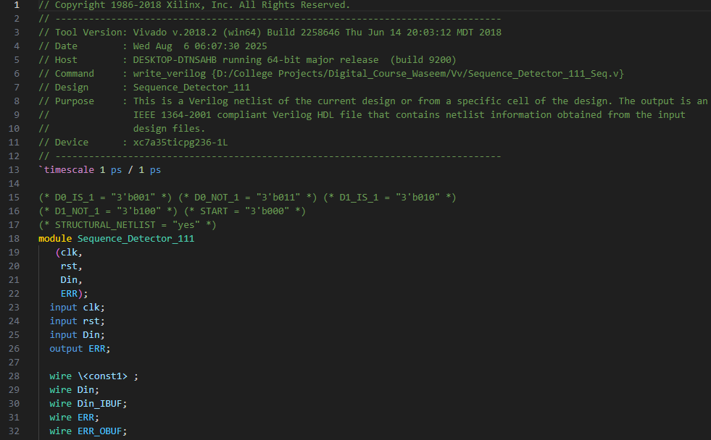

Figure 75: Q3 Netlist (Sequential)

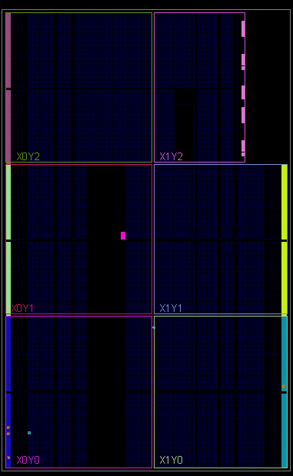

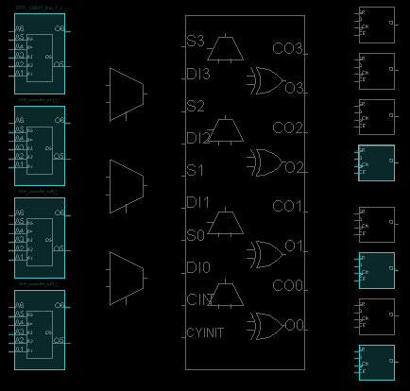

Figure 77: Q3 Zoomed Device (Sequential)

Figure 76: Q3 Device (Sequential)

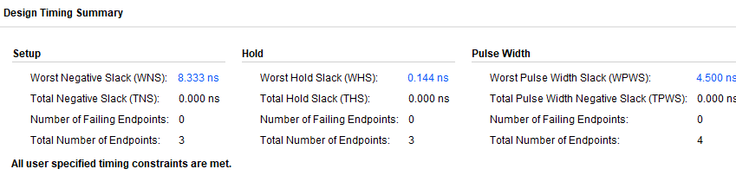

Figure 78: Q3 Synthesis Timing Report (Sequential)

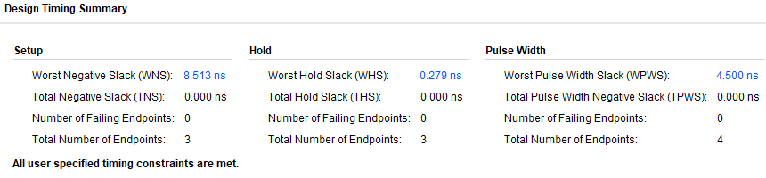

Figure 79: Q3 Implementation Timing Report (Sequential)

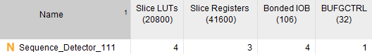

Figure 80: Q3 Synthesis Utilization Report (Sequential)



Figure 81: Q3 Implementation Utilization Report (Sequential)

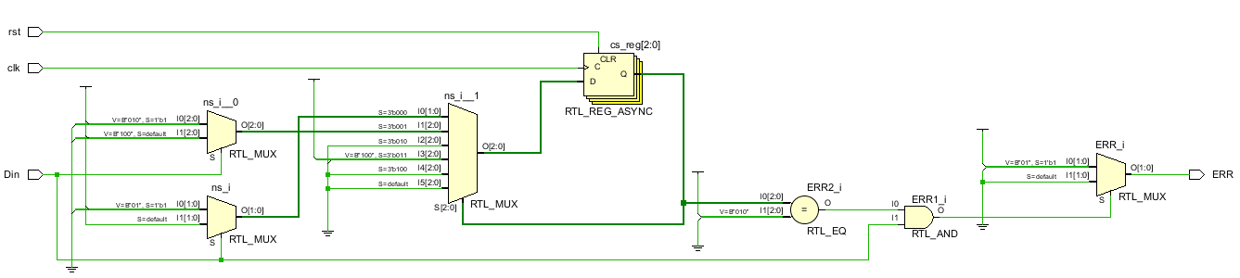 **3.3 One-Hot Encoding:**

Figure 82: Q3 RTL (One-Hot)

Figure 83: Q3 Synthesis (One-Hot)

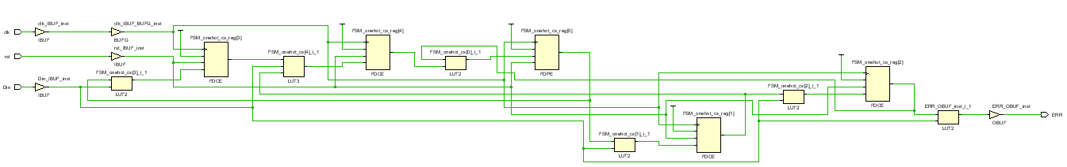

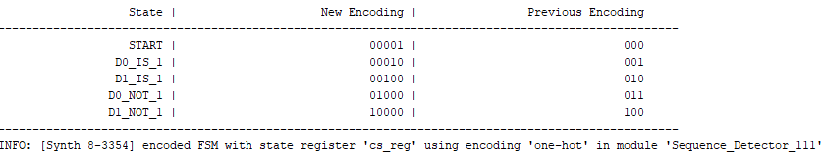

Figure 84: Q3 Encoding Report (One-Hot)

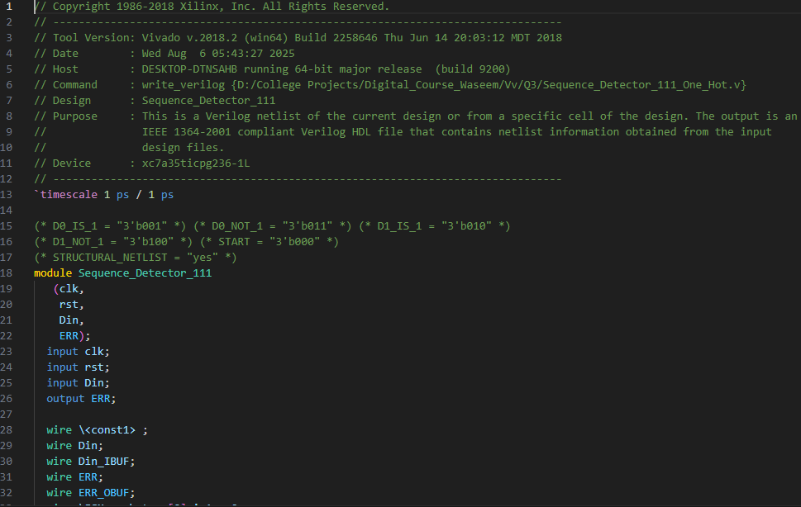

Figure 85: Q3 Netlist (One-Hot)

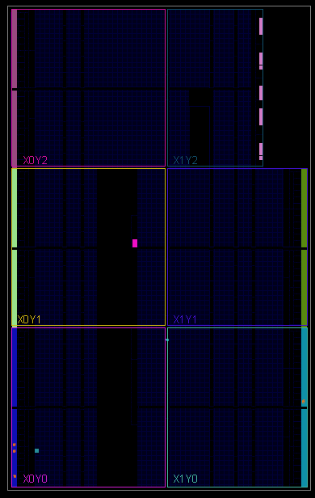

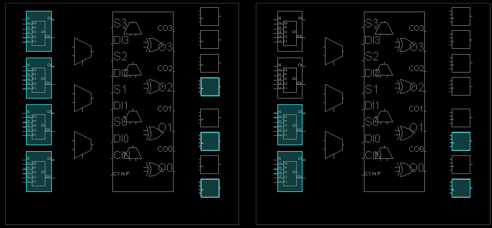

Figure 87: Q3 Zoomed Device (One-Hot)

Figure 86: Q3 Device (One-Hot)

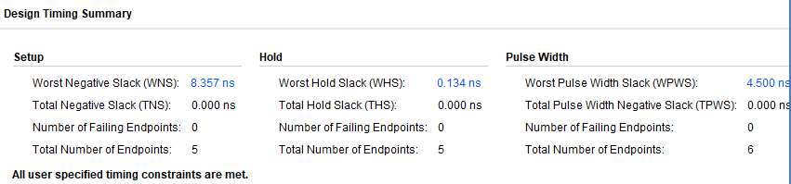

Figure 88: Q3 Synthesis Timing Report (One-Hot)

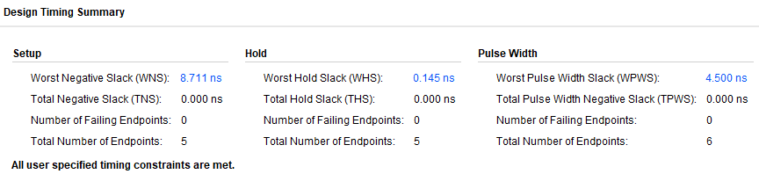

Figure 89: Q3 Implementation Timing Report (One-Hot)

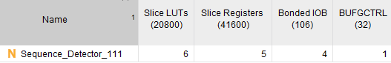

Figure 90: Q3 Synthesis Utilization Report (One-Hot)

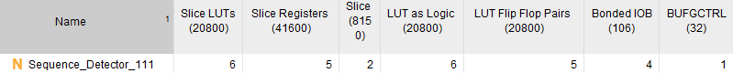

Figure 91: Q3 Implementation Utilization Report (One-Hot)

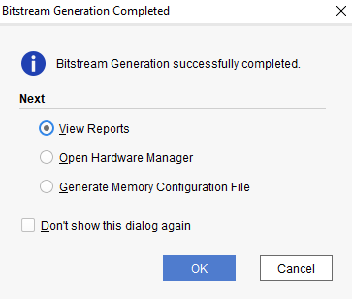

Figure 92: Q3 Bitstream

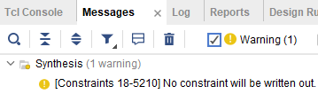

Figure 93: Q3 Messages

* If we want to use the highest frequency, then we choose **One Hot** encoding, as it has the highest setup time slack.
* If we want minimum area, we choose **Sequential** or **Gray** encoding, as they use less components than One Hot encoding.

**4. Pipelined RAM:**

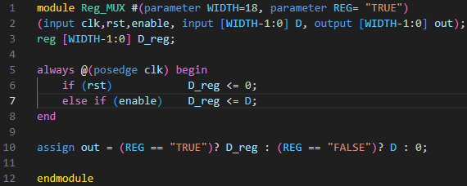

Figure 94: Q4 Reg with MUX

Figure 95: Q4 Code

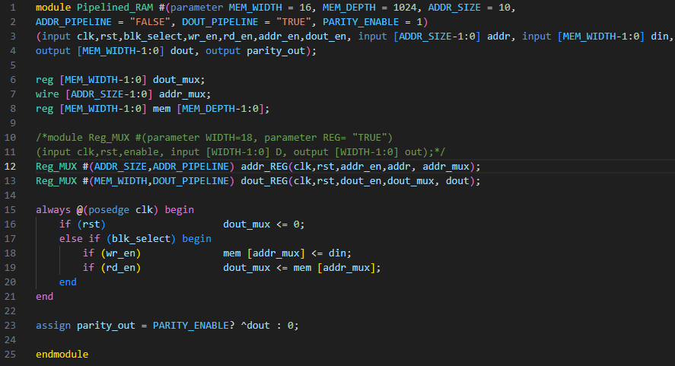

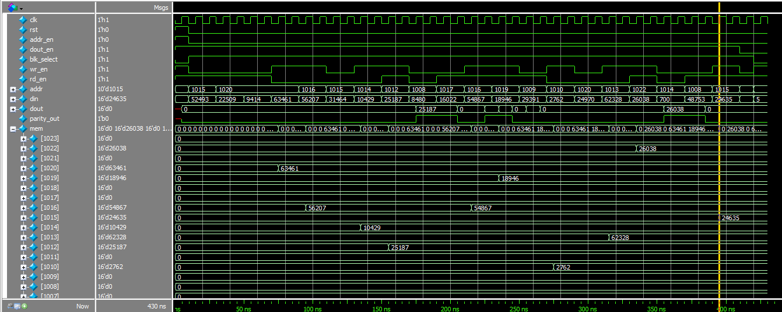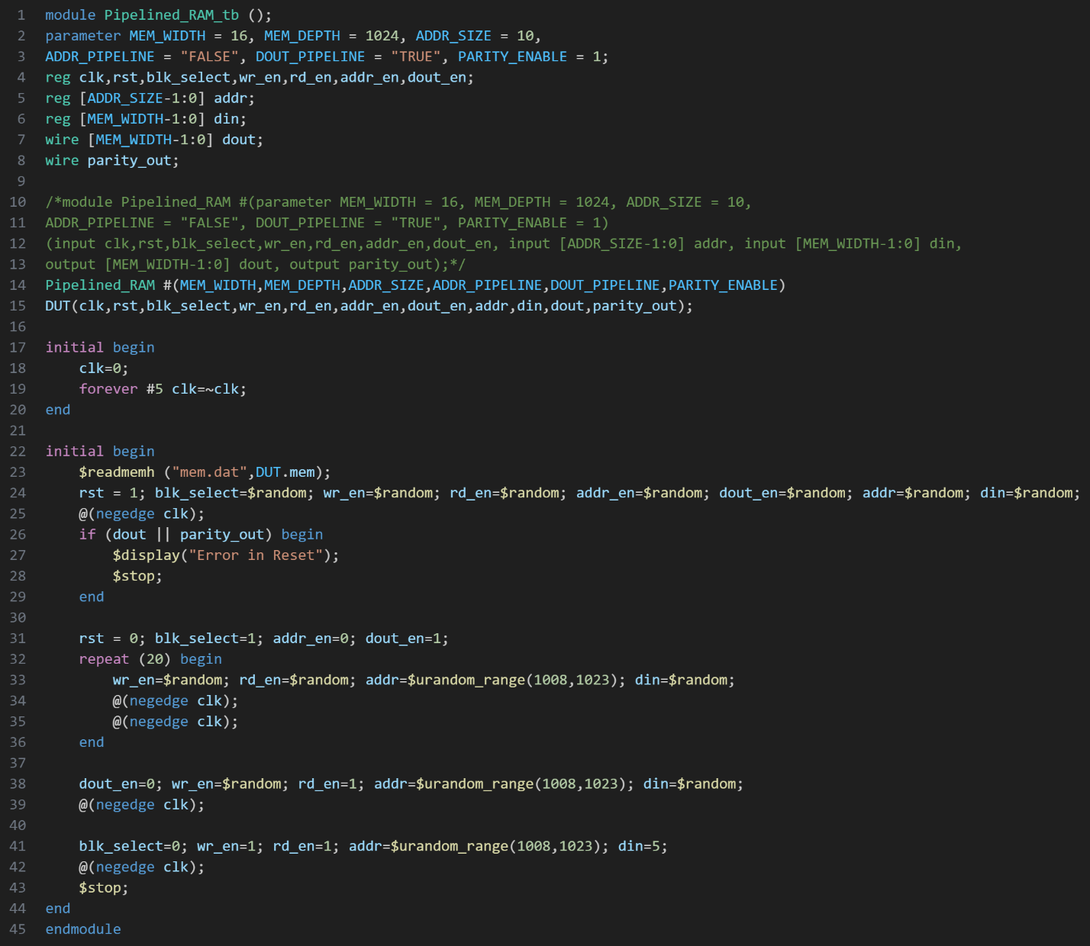

Figure 96: Q4 Testbench

Figure 97: Q4 Wave

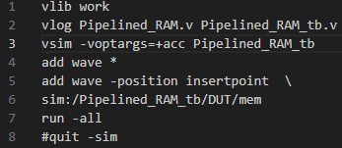

Figure 98: Q4 DO File

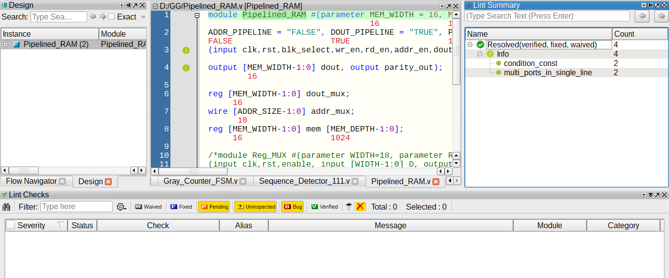

Figure 99: Q4 Linting

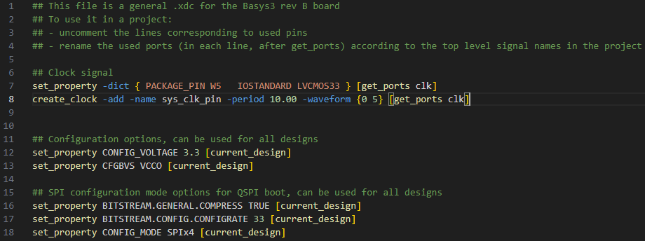

*Figure 100: Q4 Constraint File*

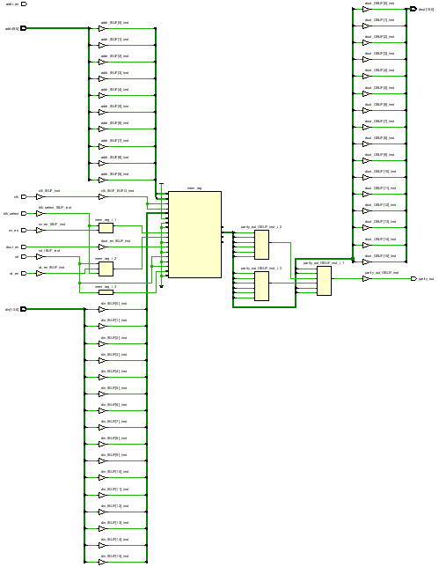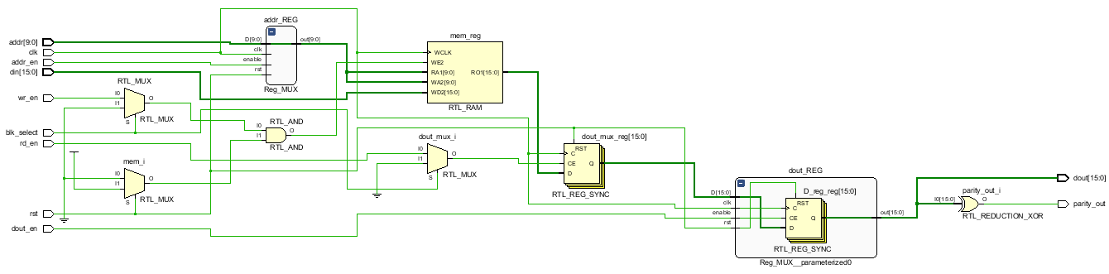

*Figure 101: Q4 RTL*

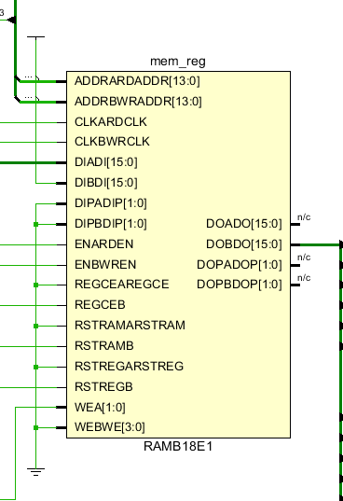

*Figure 102: Q4 Synthesis*

*Figure 103: Q4 RAM Synthesis*

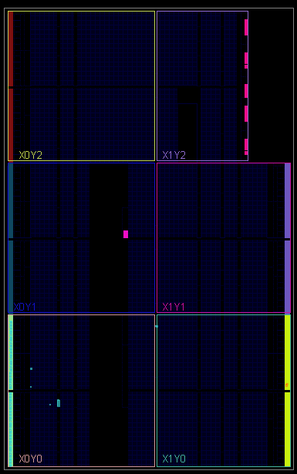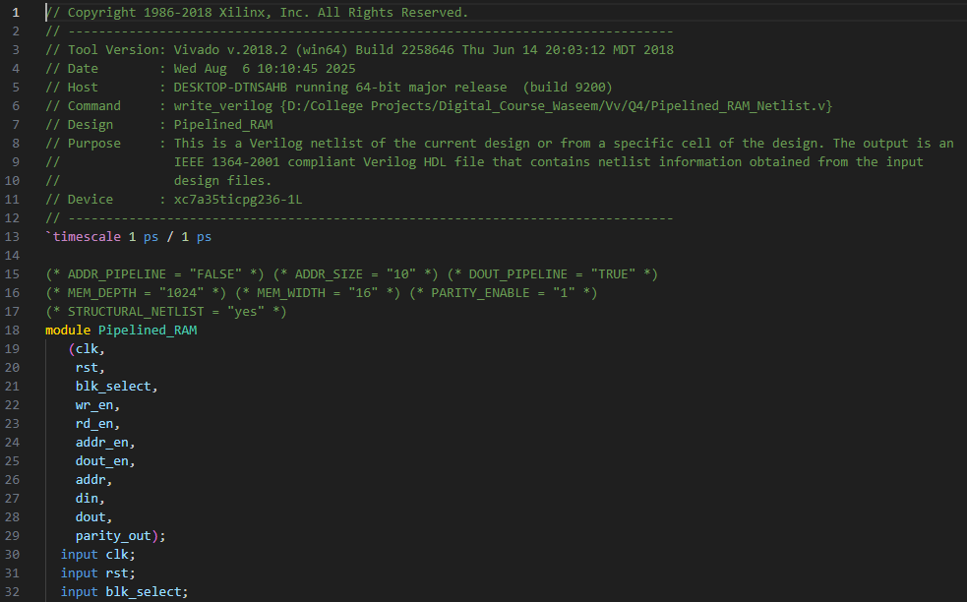

*Figure 104: Q4 Netlist*

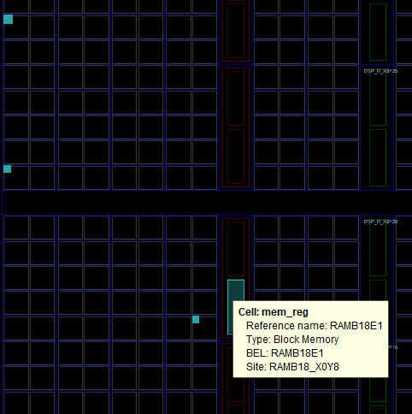

*Figure 106: Q4 Zoomed Device*

*Figure 105: Q4 Device*

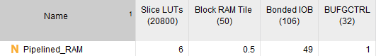

*Figure 107: Q4 Synthesis Utilization Report*

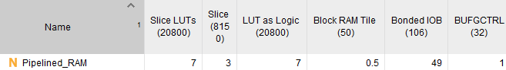

*Figure 108: Q4 Implementation Utilization Report*

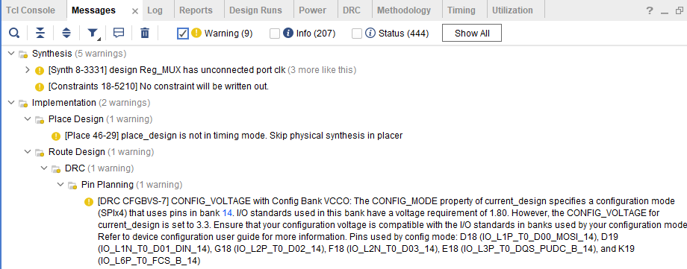

*Figure 109: Q4 Messages*

**صورة تحتوي على نص, لقطة شاشة, برمجيات

قد يكون المحتوى المعد بواسطة الذكاء الاصطناعي غير صحيح.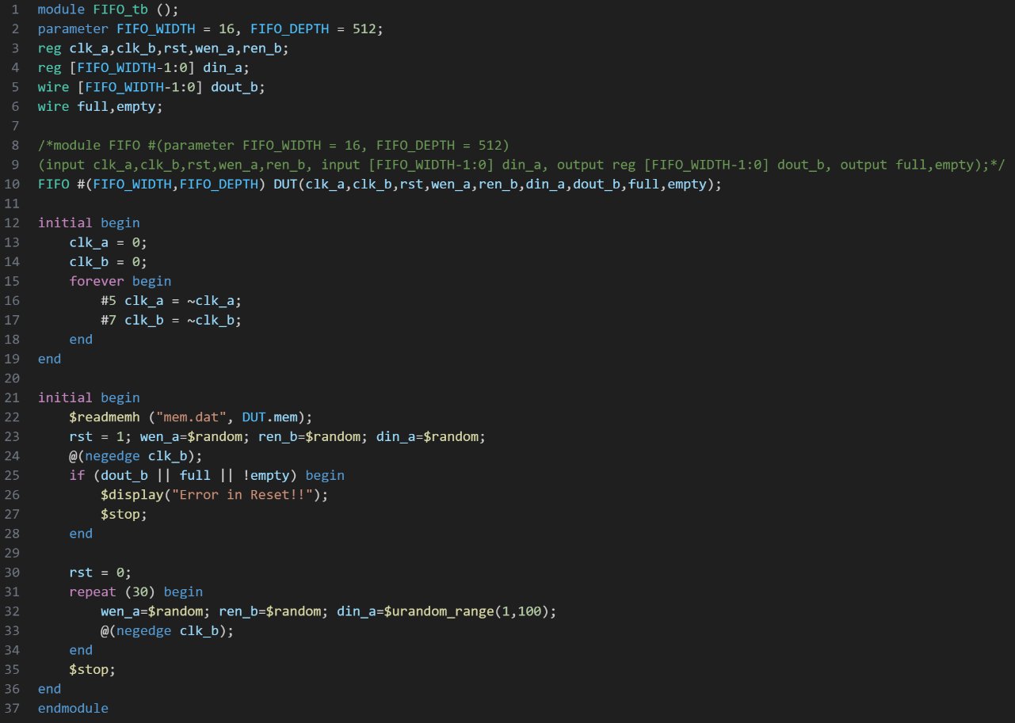5. FIFO:**

*Figure 111: Q5 Testbench*

*Figure 110: Q5 Code*

**صورة تحتوي على نص, برمجيات, أيقونة الحاسوب, صفحة ويب

قد يكون المحتوى المعد بواسطة الذكاء الاصطناعي غير صحيح.صورة تحتوي على لقطة شاشة, الفراغ/ الفضاء, خط

قد يكون المحتوى المعد بواسطة الذكاء الاصطناعي غير صحيح.صورة تحتوي على لقطة شاشة, الإلكترونيات, خط, الهندسة الإلكترونية

قد يكون المحتوى المعد بواسطة الذكاء الاصطناعي غير صحيح.**

*Figure 113: Q5 Linting*

*Figure 112: Q5 Wave*

**صورة تحتوي على نص, لقطة شاشة, الخط

قد يكون المحتوى المعد بواسطة الذكاء الاصطناعي غير صحيح.**

*Figure 114: Q5 DO File*

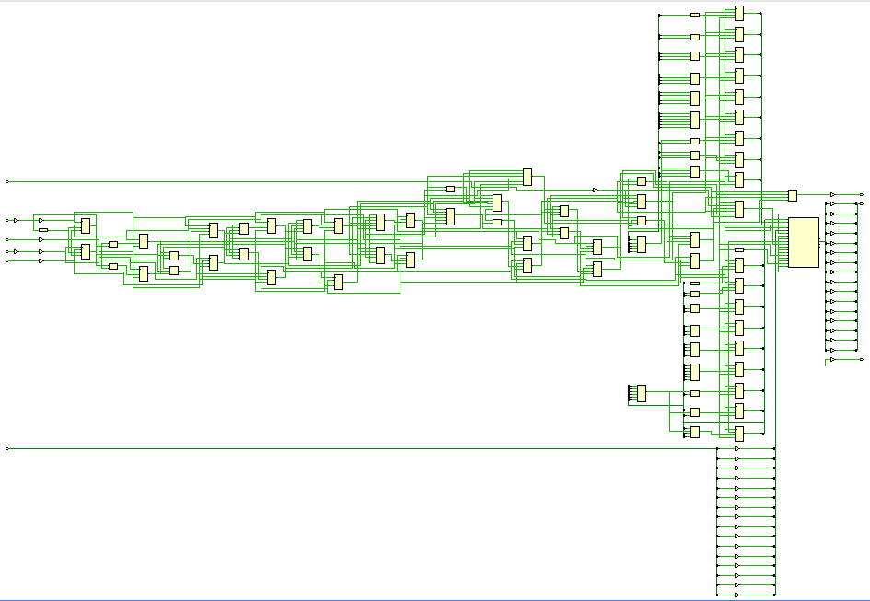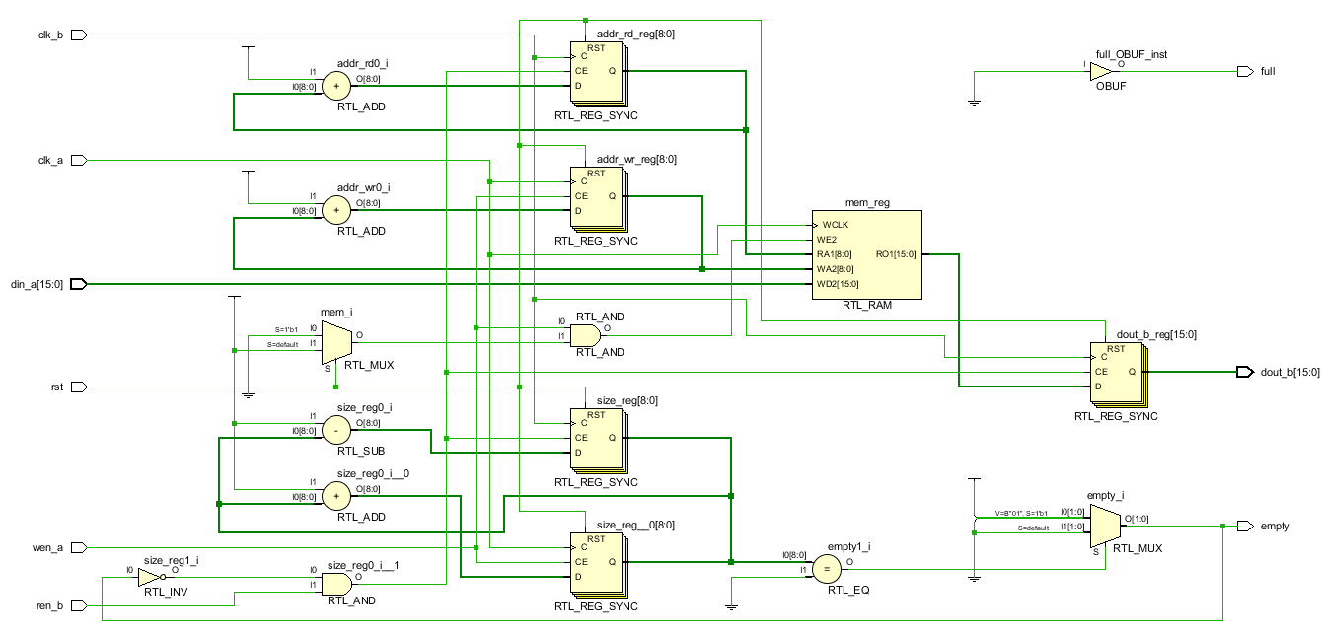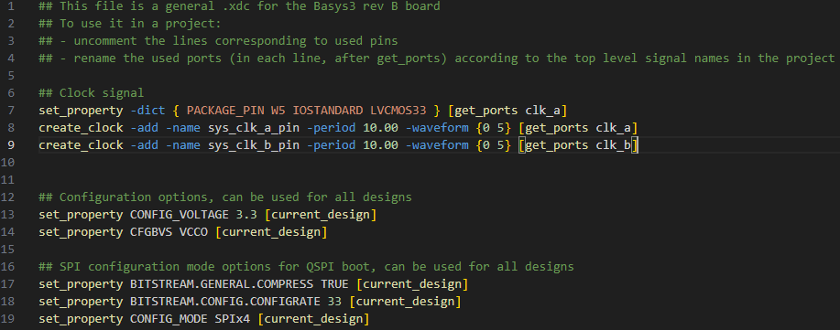

*Figure 116: Q5 RTL*

*Figure 115: Q5 Constraint File*

*Figure 117: Q5 Synthesis*

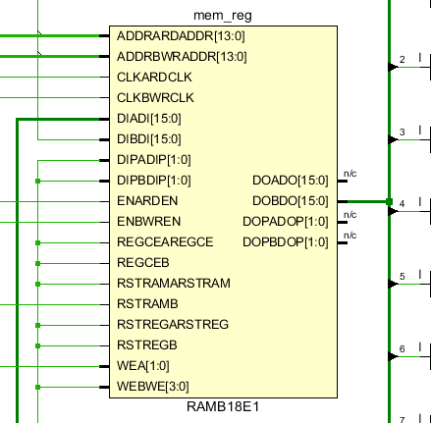

*Figure 118: Q5 RAM Synthesis*

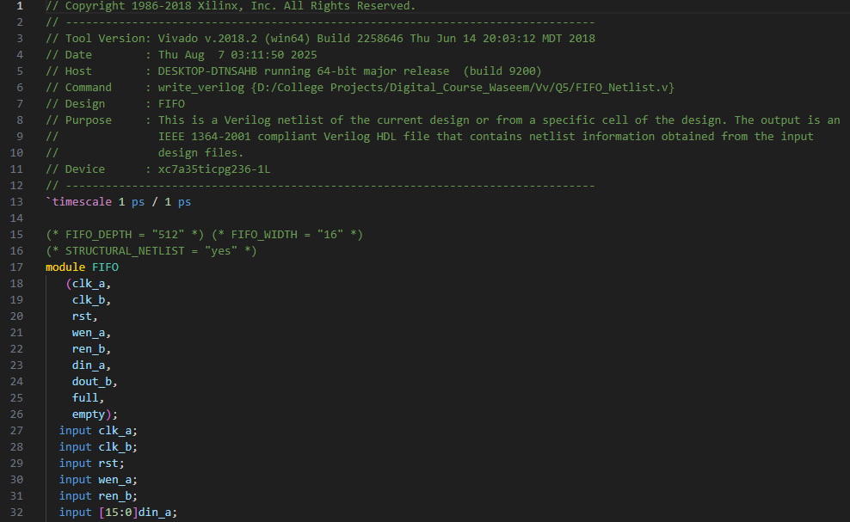

*Figure 119: Q5 Netlist*

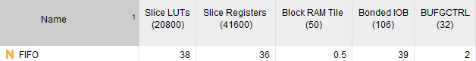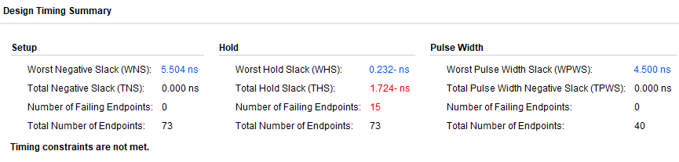

*Figure 121: Q5 Synthesis Utilization Report*

*Figure 120: Q5 Synthesis Timing Report*

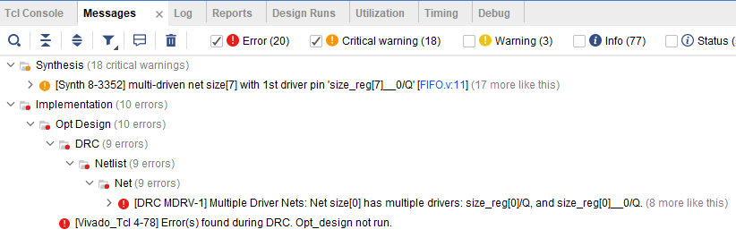

*Figure 122: Q5 Messages*

The critical warning is due to "size" being assigned in two different always blocks.. I tried to figure out another way to get the logic of "full" and "empty" without "size", or try to manipulate "size" in another way that do the same functionality without any errors, but I couldn't think of anything.

**6. IP ALSU:**

**صورة تحتوي على نص, لقطة شاشة, برمجيات

قد يكون المحتوى المعد بواسطة الذكاء الاصطناعي غير صحيح.**What changed in the RTL code due to using IPs:

*Figure 123: Q6 Code (1)*

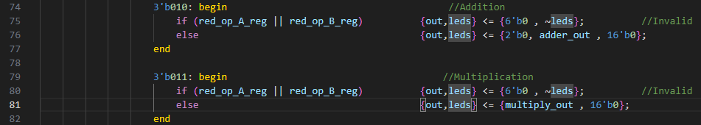

*Figure 124: Q6 Code (2)*

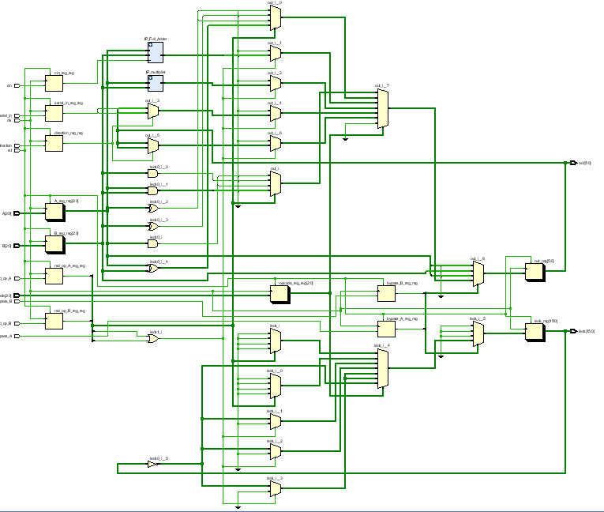

*Figure 125: Q6 RTL*

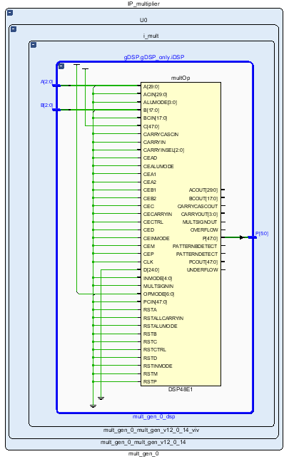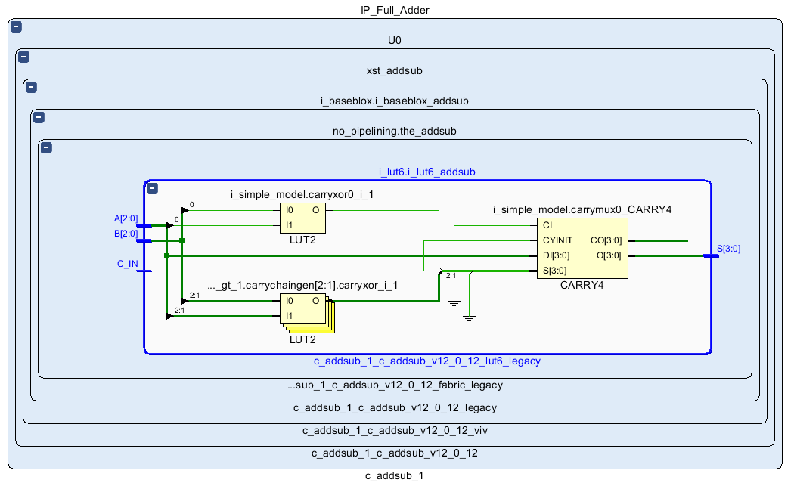

*Figure 126: Q6 IP Adder RTL*

*Figure 127: Q6 IP Multiplier RTL*

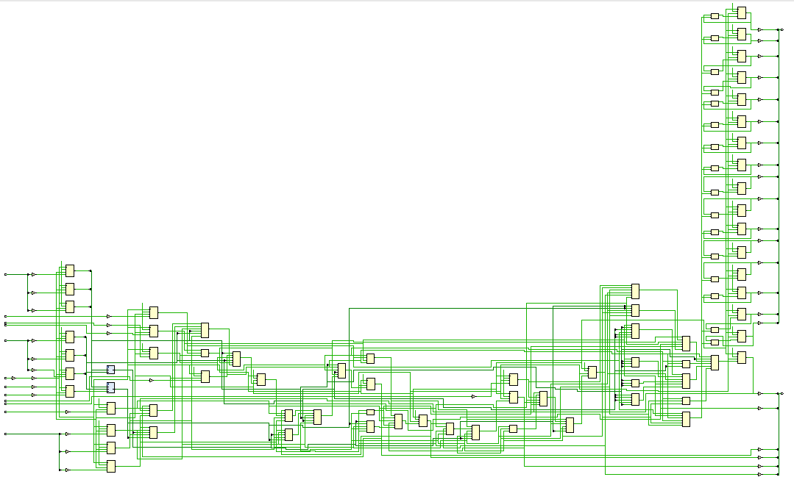

*Figure 128: Q6 Synthesis*

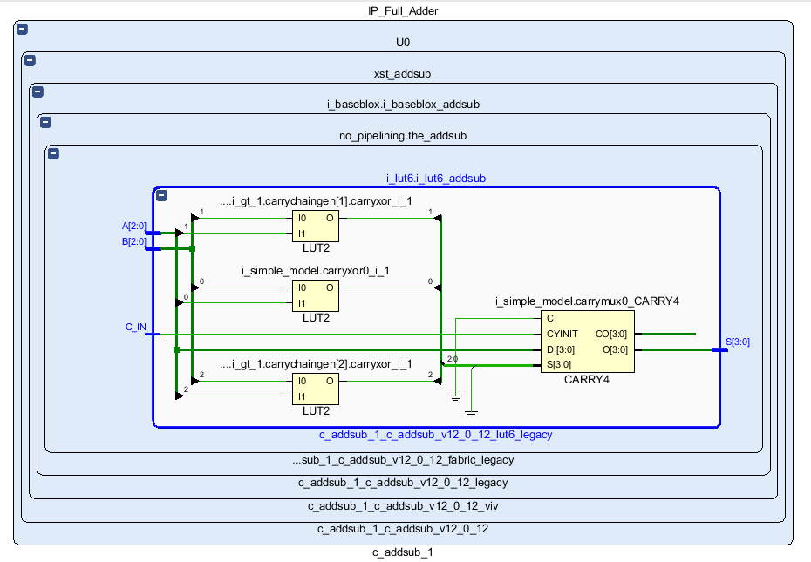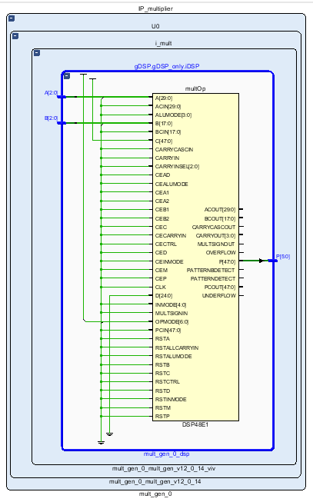

*Figure 130: Q6 IP Multiplier Synthesis*

*Figure 129: Q6 IP Adder Synthesis*

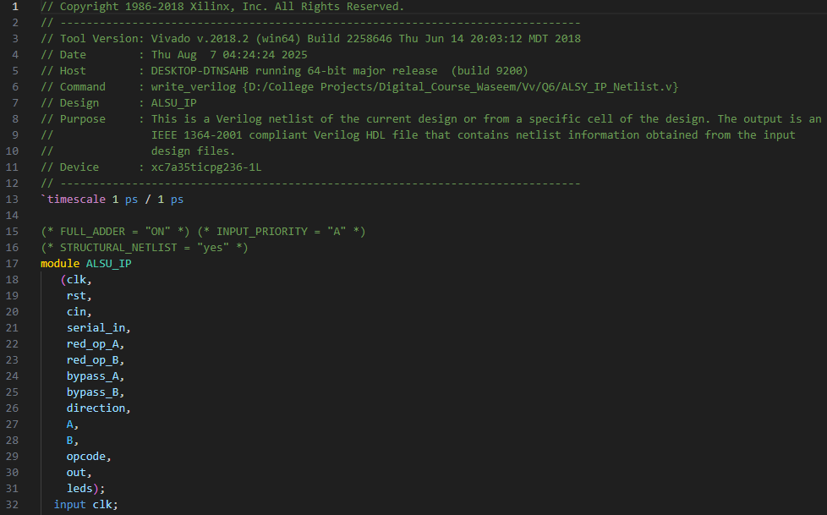

Figure 131: Q6 Netlist

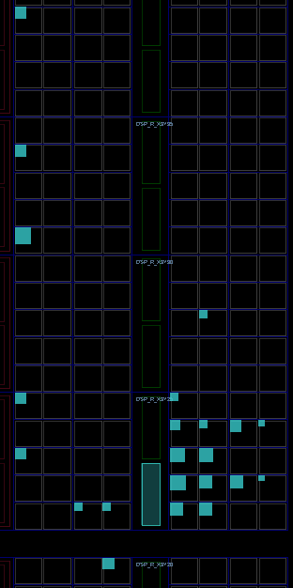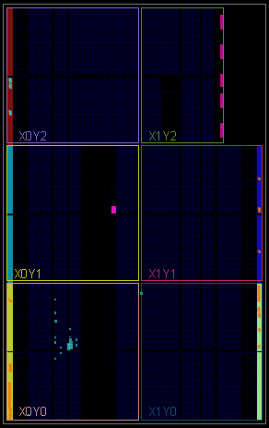

Figure 133: Q6 Zoomed Device

Figure 132: Q6 Device

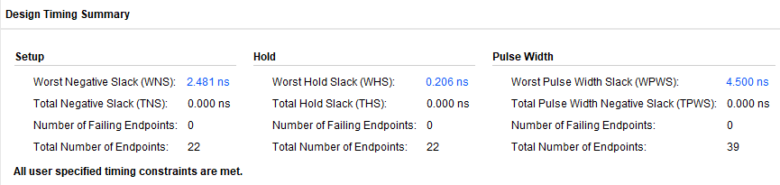

Figure 134: Q6 Synthesis Timing Report

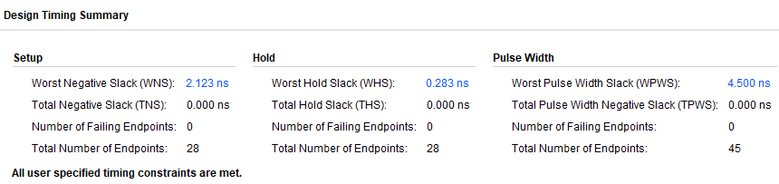

Figure 135: Q6 Implementation Timing Report

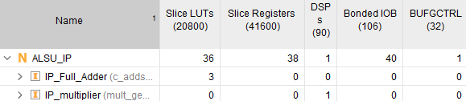

Figure 136: Q6 Synthesis Utilization Report

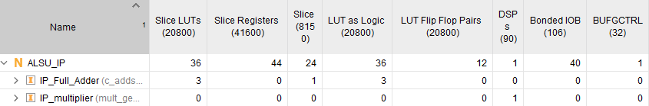

Figure 137: Q6 Implementation Utilization Report

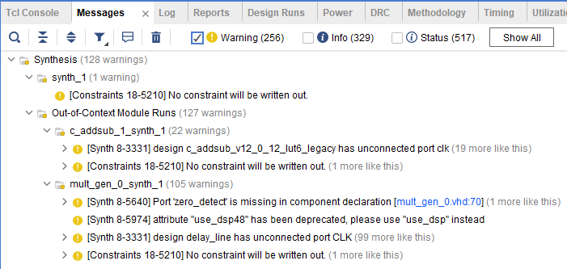

Figure 138: Q6 Messages